**Mess Api requirement.**

1. There are 3 roles to use this software.
2. Owner: all rights
3. Admin: only attendance and clerical rights.
4. 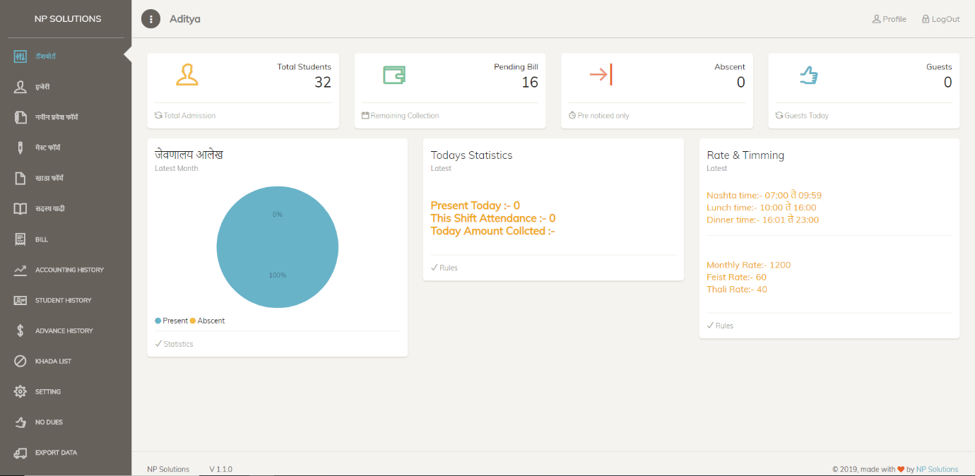Attender: only attendance

As you can see this old dashboard screen above.

There you can see no of active student of this current year.

Current year pending bills, Total guests today, Total absent today, Graph also, and other statistics.

Attendance

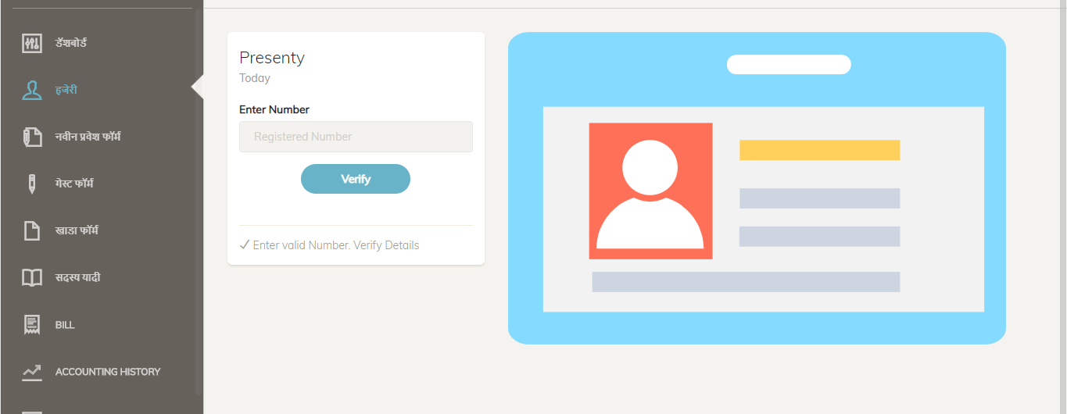This is first appearance of attendance page

2nd screen is that small info of student will appear.

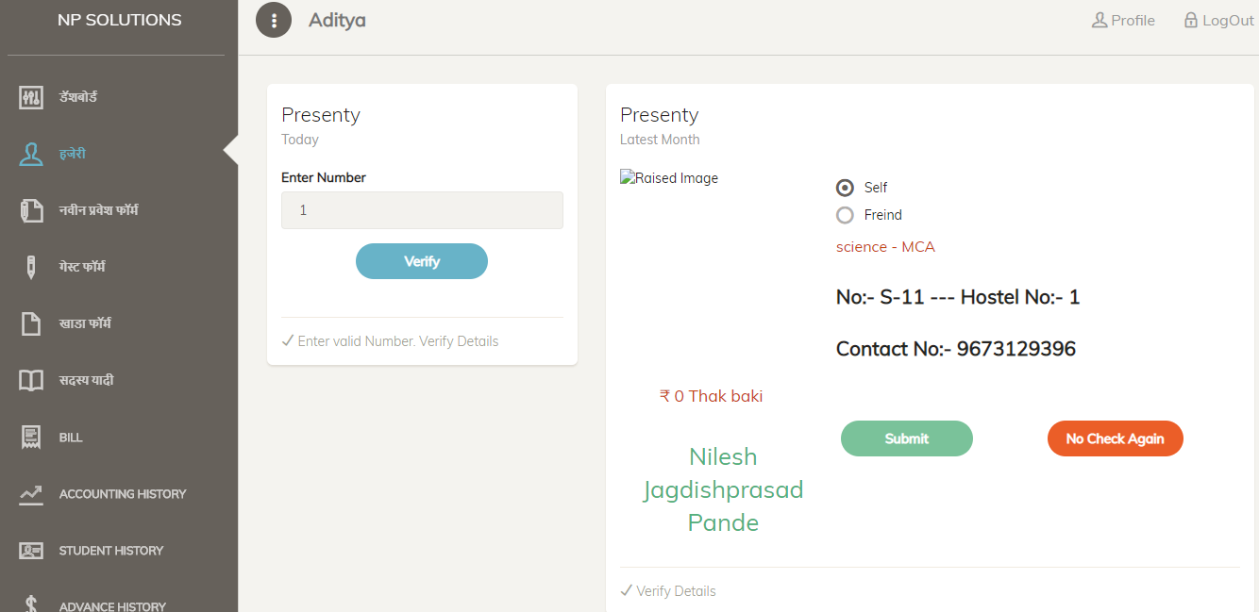

Here you have to match student face with this pohoto and then click on submit

It will make attendance.

Admission form

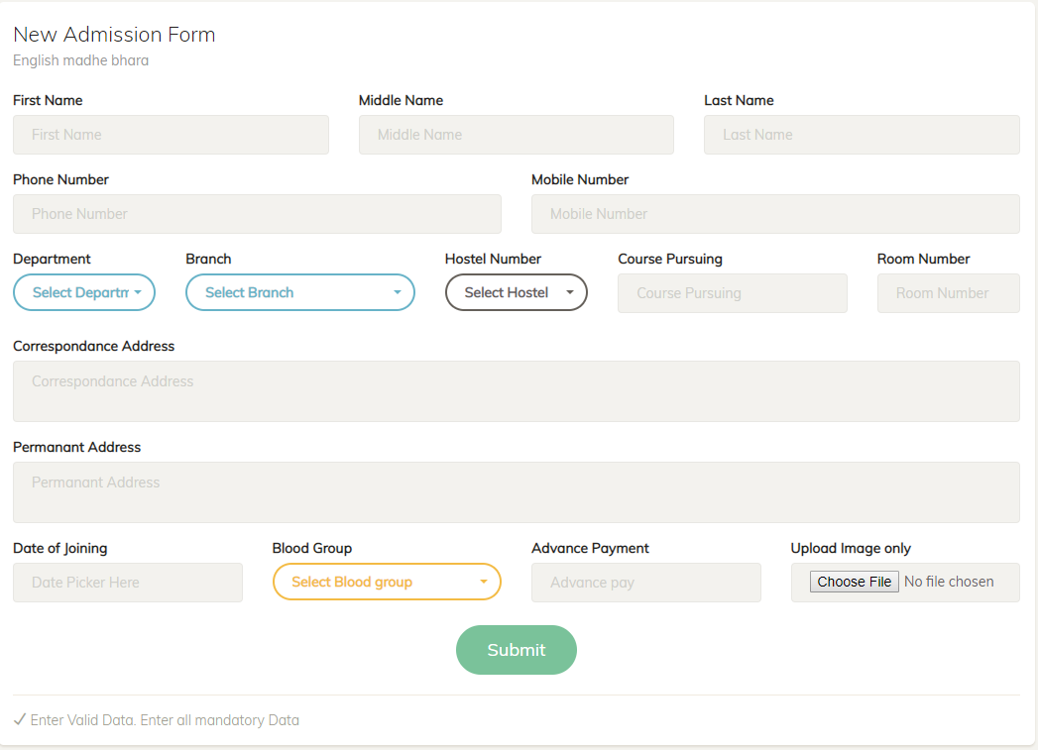This is form view with essential fields

The other information to be save in table . those fields are in old database file plz check..

There are some drop down those fields are also dynamic. Those fields can also be change by mess confile file.

Guest

Here is first look

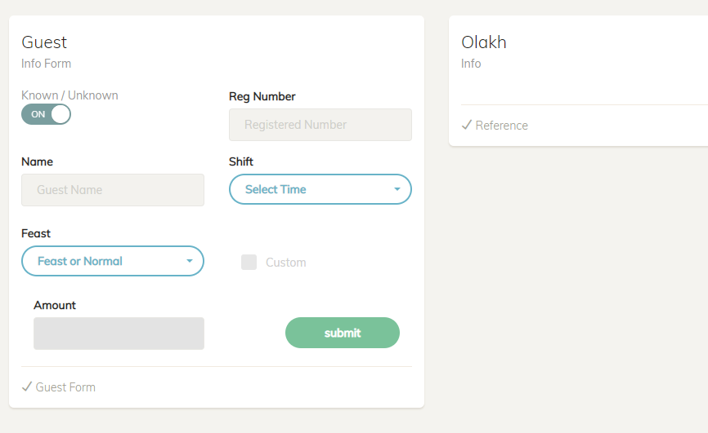

Here you can add either known guest of unknown guest.

If known guest only then you can add reg ID so that bill will add into billing cycle of that particular reg id student.

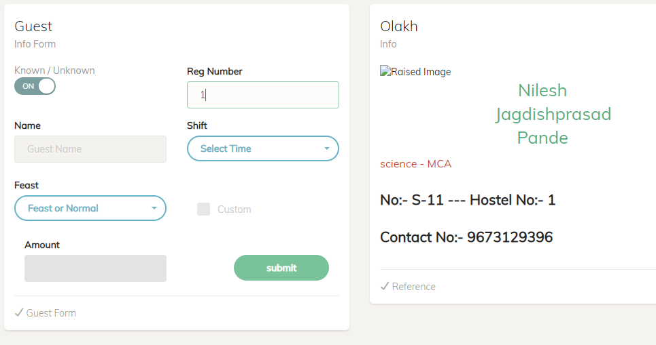

Khada

Here is first view of khada form. In this student can give pre notification of his absence. Otherwise khada will not be considered.

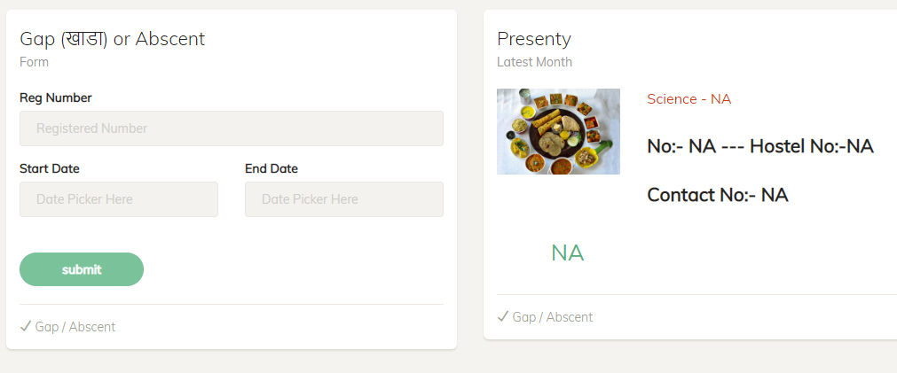

After entering Reg id user can only add start day from tomorrow only.

And any end date. But Owner allowed only 3 khada of month.

That khada limit can be changed from config form table.

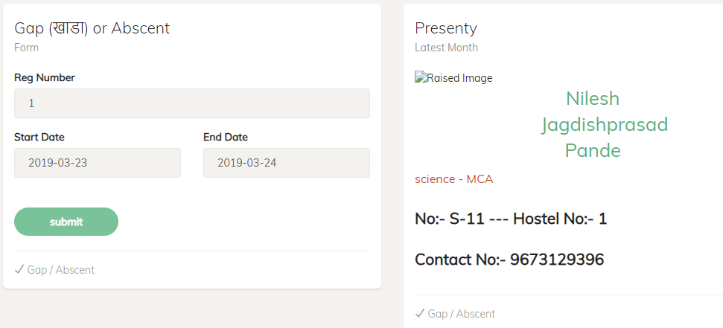

Member list

This is list only this current year with any kind of status

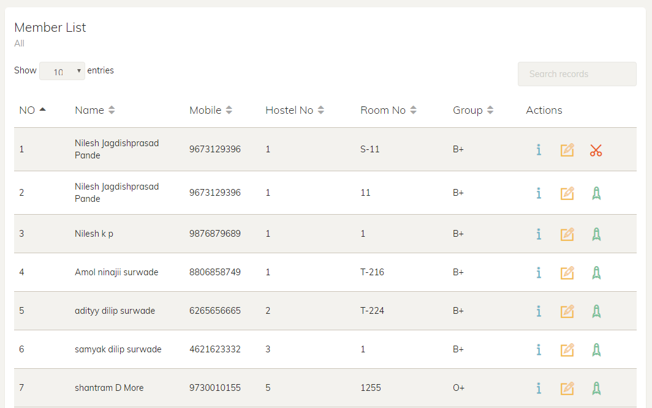

Red button shows this member is active but you can deactivate him

And green button shows its deactivated but you can reactivate him.

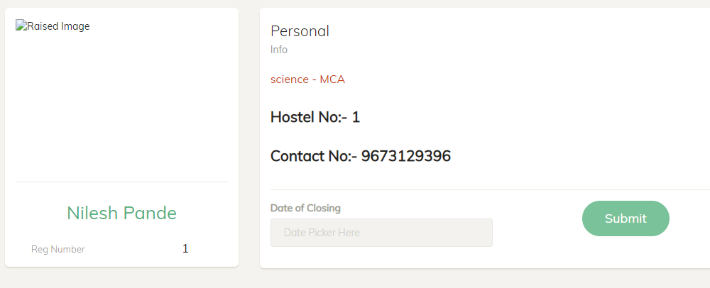

After clicking on deactivate button this screen will appear and will ask for date of closing

That date will be help ful to calculate all previous pending or extra payment.

After giving date click on submit

It will calculate bills as shown in below pic

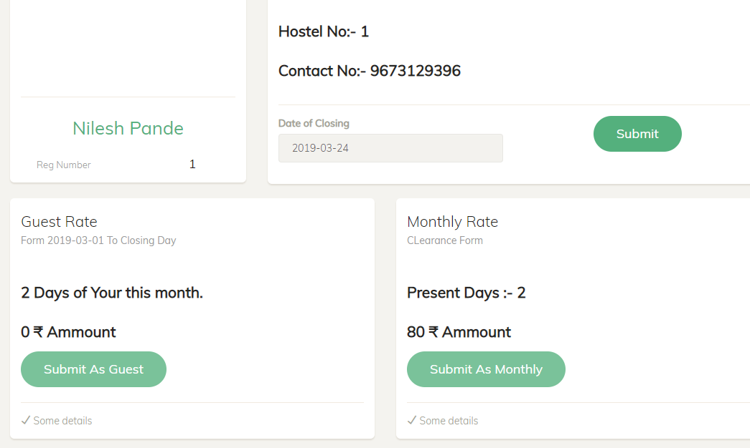

Then you have to choose these options

Guest rate will calculate al your mills as guest rate

And monthly will calculate monthly bill .

User can choose his benefit and can submit according to that.

User must take payment here now.

For reactivation just simply click on that button and then next submit button.

Bill

This is list of active memebrs bill list

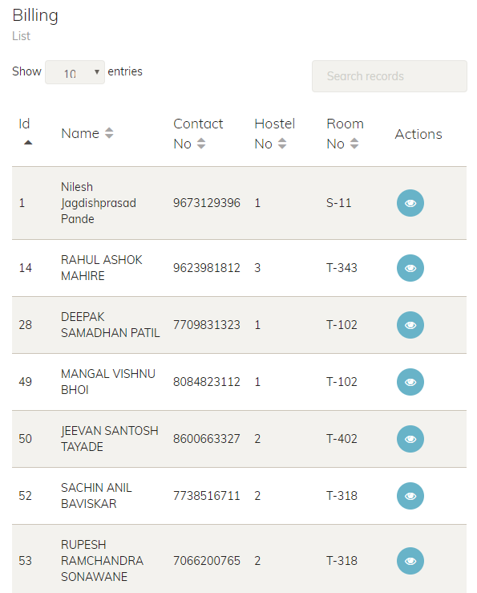

By clicking on that eye button you can see bills 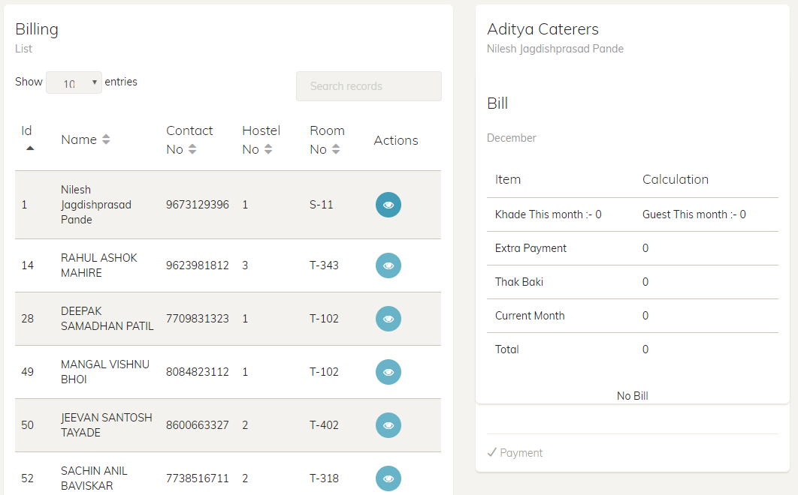

Account History

Here by entering Reg id it will show all history of payments from start date to till date. And can print it any time.

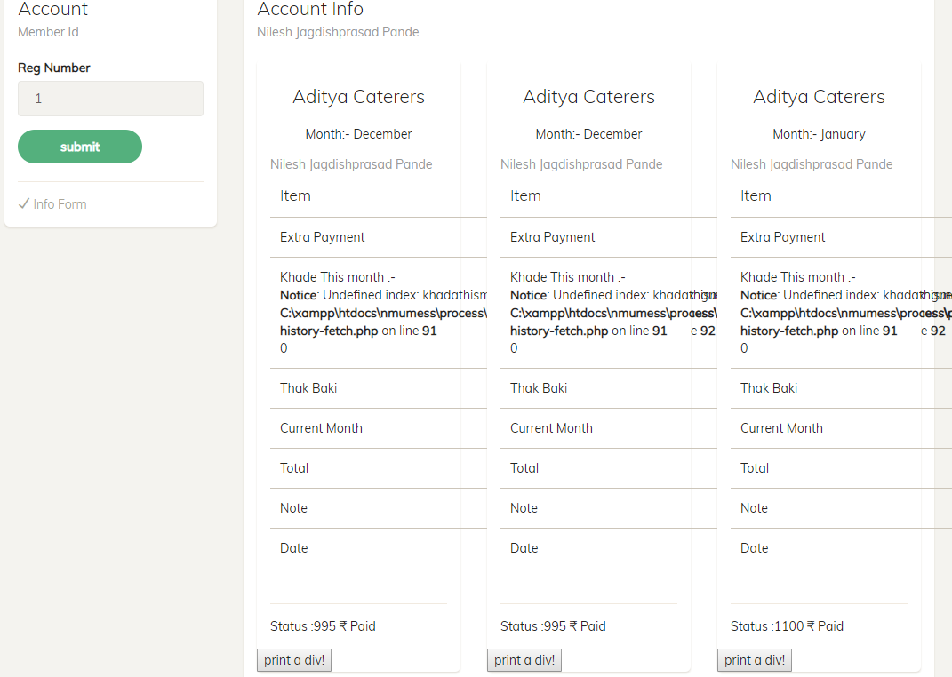

Student History

Here by entering student reg id you can see which date he have taken food

On which session

On which time.

All record was stored in presenty table in background

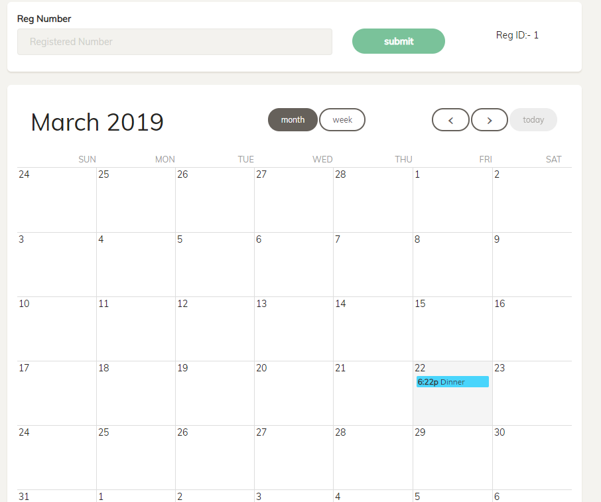

See pic clearly. That clear data to be shown.

Khada LIst

Here member can see when and how much long khada he have taken.

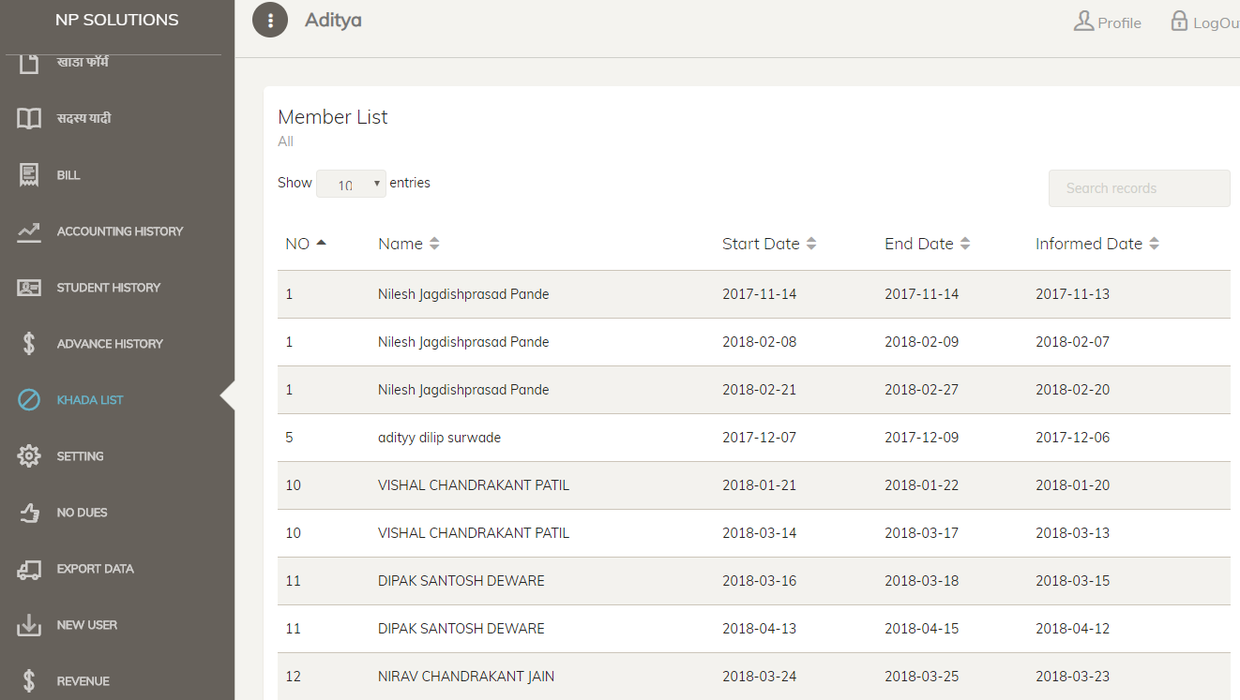

Software setting

Here you can customise some setting by owner of mess

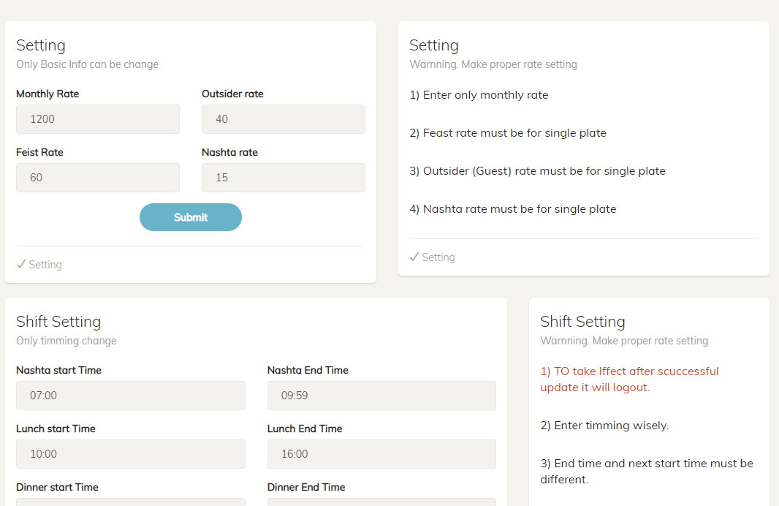

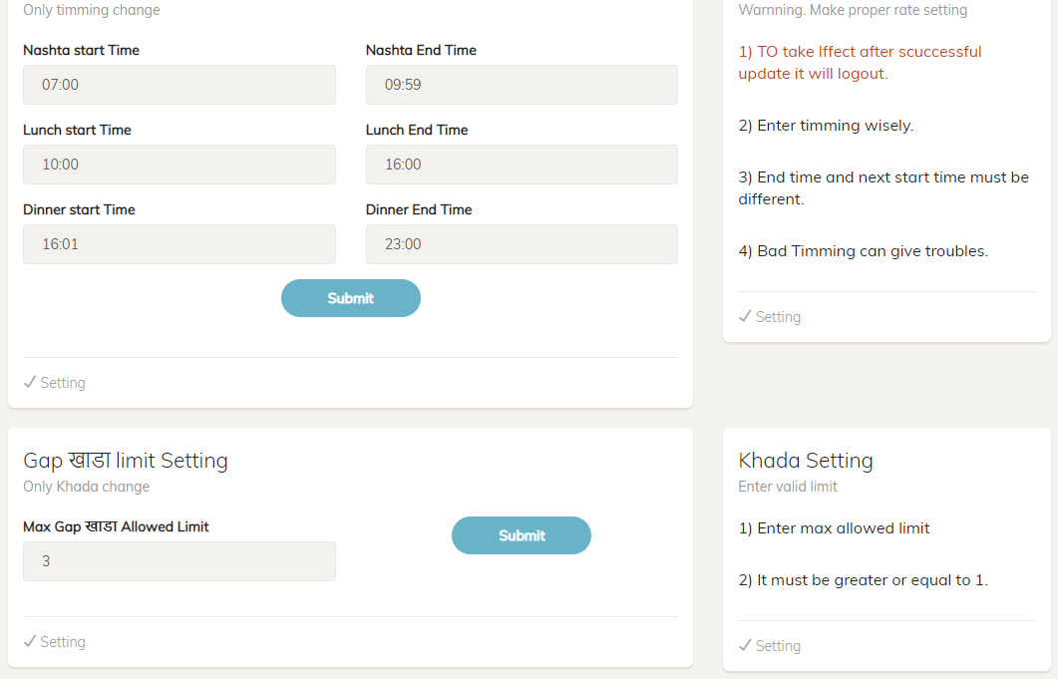

There are some more things gonna come here.

All this things gonna store in db

No dues

To check all pending payments to give no dues certificate.

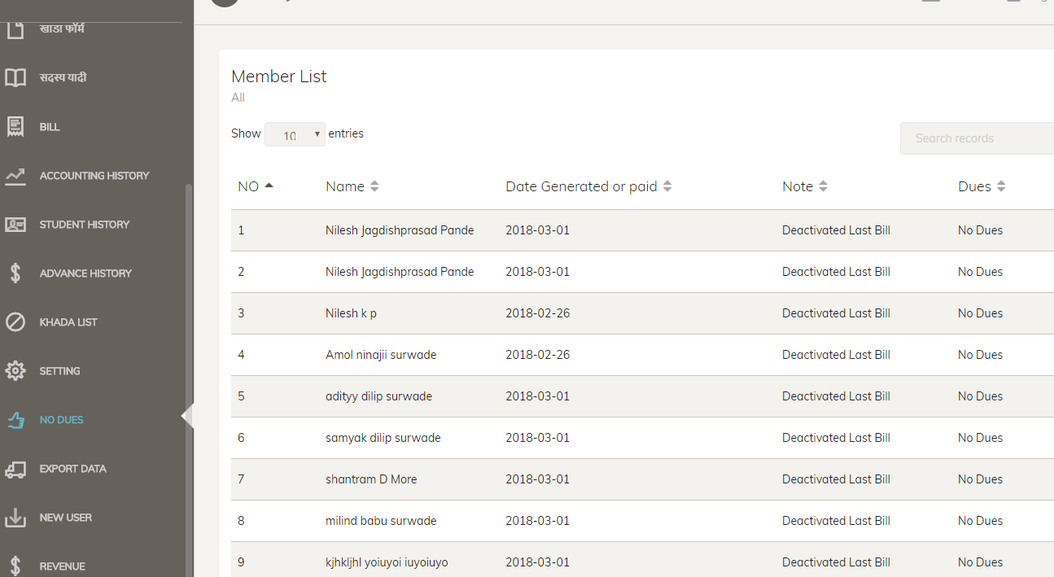

Data Export

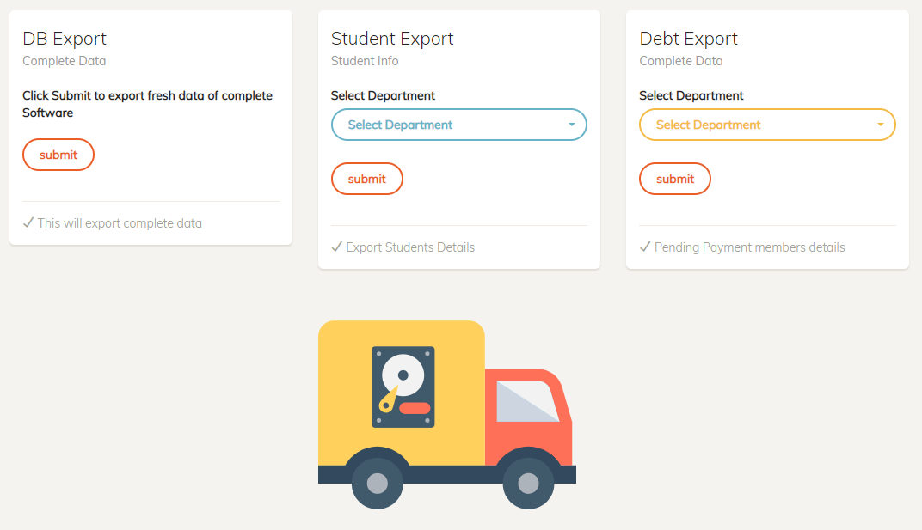

New User

Owner of mess can add another user so he can manage this things.

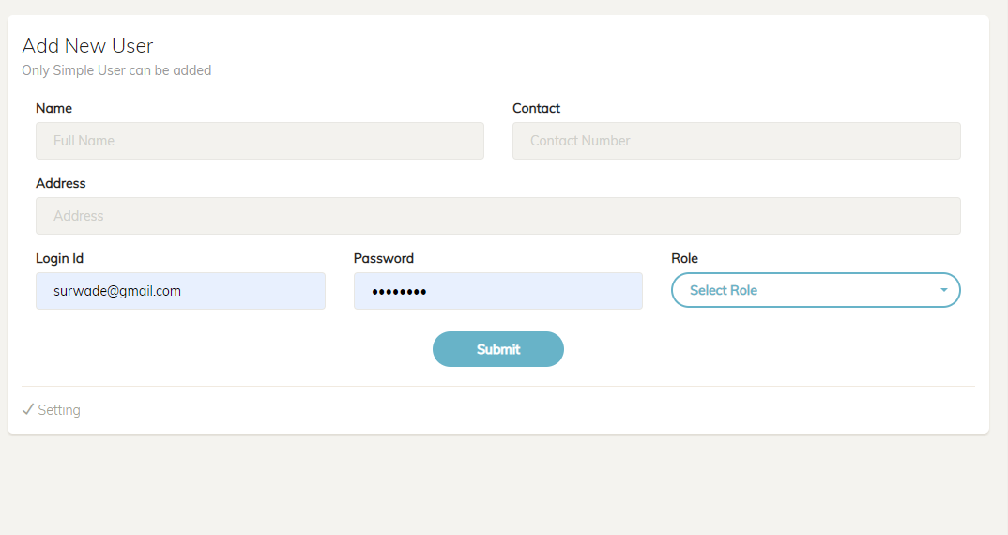

Db of old mess

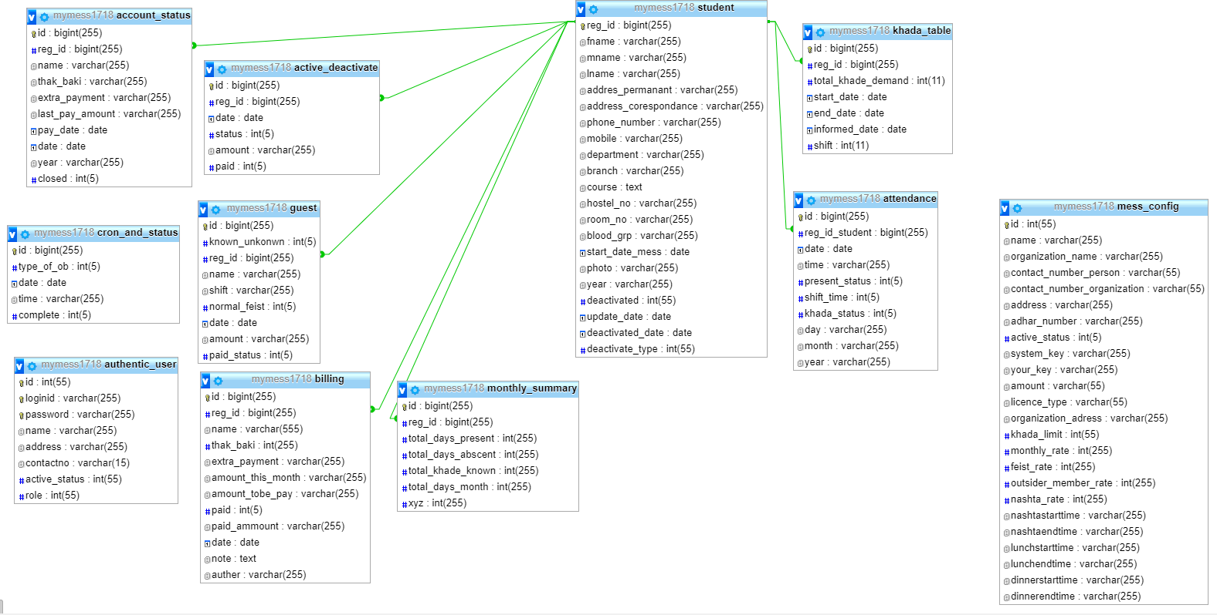

Bill must be calculated on periodically automatically.

With consideration all history of payments.